**Experiment No 7**

**Aim**: Implement java programs based on arrays.

**Code :**

class Data

{

public static void main(String[] args)

{

int[] marks =new int[5];

marks[0]=95;

marks[1]=98;

marks[2]=85;

marks[3]=70;

marks[4]=64;

for(int i=0;i<5;i++)

{

System.out.println("marks are: "+marks[i]);

}

}

}

**Output :**

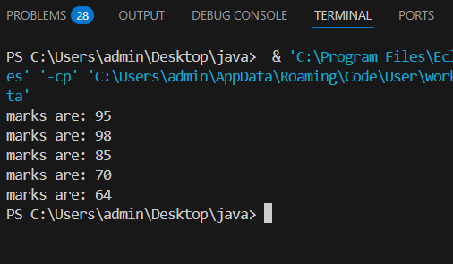

**Code :**

import java.util.Scanner;

class Data

{

public static void main(String[] args)

{

Scanner sc = new Scanner(System.in);

System.out.print("enter size: ");

int size= sc.nextInt();

int number[] = new int[size];

System.out.print("enter numbers: ");

for(int i=0;i<size;i++)

{

number[i]=sc.nextInt();

}

for(int i=0;i<size;i++)

{

System.out.println("numbers are: "+number[i]);

}

} }

**Output :**

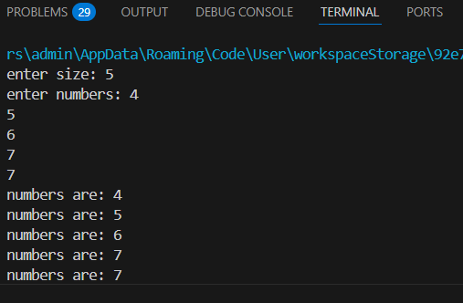

**Java Array Program to Find the Largest Element in an Array**

**Code :**

class Element

{

public static void main(String[] args)

{

int[] arr = {20, 10, 20, 4, 100};

int max = arr[0];

for (int i = 1; i < arr.length; i++)

{

if (arr[i] > max)

{

max = arr[i];

}

}

System.out.println("Largest element in the array: " + max);

}

}

**Output :**

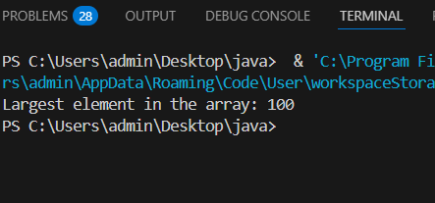

**Java Array Program to Copy All the Elements of One Array to Another Array**

**Code :**

public class Sample {

public static void main(String[] args)

{

int[] arr = {10, 20, 30, 40, 50};

int[] copyarr = new int[arr.length];

for (int i = 0; i < arr.length; i++) {

copyarr[i] = arr[i];

}

System.out.print("Original Array: ");

for (int i = 0; i < arr.length; i++) {

System.out.print(arr[i] + " ");

}

System.out.println();

System.out.print("Copied Array: ");

for (int i = 0; i < copyarr.length; i++) {

System.out.print(copyarr[i] + " ");

}

System.out.println();

} }

**Output :**

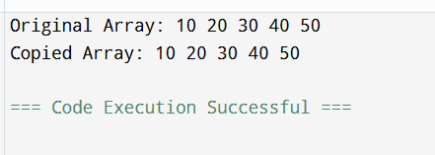

**Java Array Program to Check if Two Arrays Are Equal or Not**

**Code :**

class Data

{

public static void main(String[] args)

{

int a[] = {10, 20, 30};

int b[] = {10, 20, 30};

if(a == b)

{

System.out.println("both arrays are same");

}

else

{

System.out.println("both arrays are not same");

} }

}

**Output :**

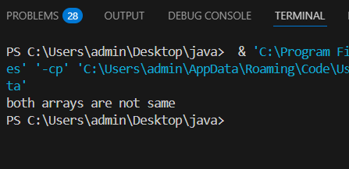

**Java Array Program to Sort the Elements of an Array in Descending Order**

**Code :**

class Descending {

public static void main(String[] args)

{

int[] arr = {10, 20, 30, 40, 50};

for (int i = 0; i < arr.length - 1; i++) {

for (int j = 0; j < arr.length - 1 - i; j++)

{

if (arr[j] < arr[j + 1]) {

int temp = arr[j];

arr[j] = arr[j + 1];

arr[j + 1] = temp;

} }

}

System.out.print("Sorted Array in Descending Order: ");

for (int i = 0; i < arr.length; i++) {

System.out.print(arr[i] + " ");

} }

}

**Output :**

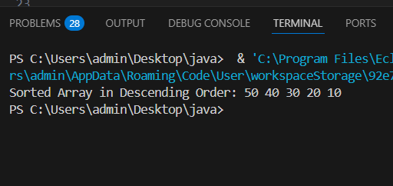

**Java Array Program to Sort the Elements of an Array in Ascending Order**

**Code :**

class Ascending {

public static void main(String[] args) {

int[] arr = {10, 20, 30, 40, 50};

for (int i = 0; i < arr.length - 1; i++) {

for (int j = 0; j < arr.length - 1 - i; j++) {

if (arr[j] > arr[j + 1]) {

int temp = arr[j];

arr[j] = arr[j + 1];

arr[j + 1] = temp;

}

} }

System.out.print("Sorted Array in Ascending Order: ");

for (int i = 0; i < arr.length; i++) {

System.out.print(arr[i] + " ");

}

} }

**Output :**

